DataPlanet API usage

​​

# 1. Use cases:

1. Upload a large number of files from the command line.
2. Dataset stored on a cloud VM.
3. Workflow automation.
4. Nested directory structure in dataset.

# 2. Things you need:

1. Dataplanet API key
2. Dataset DOI

# 3. API usage:

1. To upload a single file.
2. To upload multiple files in a directory.
3. To upload multiple directories.
4. To upload files in a tree format.

Firstly, get api_key and doi as mentioned above. In the examples below, we assume that our doi is doi:10.5072/xx/xxxxxx and our api_key is xxxxxxxx-xxxx-xxxx-xxxx-xxxxxxxxxxxx

## To upload a single file:

Let's say that we have a file called file.jpg

python3 data_uploader.py \

--doi doi:10.5072/xx/xxxxxx \

--key xxxxxxxx-xxxx-xxxx-xxxx-xxxxxxxxxxxx \

--file /path/to/file.jpg

## To upload multiple files in a directory:

Let’s say that we have a directory containing multiple files that we wish to upload.

python3 data_uploader.py \

--doi doi:10.5072/xxx/xxxxxx \

--key xxxxxxxx-xxxx-xxxx-xxxx-xxxxxxxxxxxx \

--dir /path/to/dir

## To upload multiple directories:

Let’s say we have a parent directory that has multiple child directories.

python3 data_uploader.py \

--doi doi:10.5072/xx/xxxxxx \

--key xxxxxxxx-xxxx-xxxx-xxxx-xxxxxxxxxxxx \

--dir /path/to/parent

## To upload files in a tree format:

Let’s say we want to add data to our dataset in a tree format.  
 For example, in a single dataset, we want to add code files and data diles

python3 data_uploader.py \

--doi doi:10.5072/xx/xxxxxx \

--key xxxxxxxx-xxxx-xxxx-xxxx-xxxxxxxxxxxx \

--dir /path/to/code_dir \  
--tree code

python3 data_uploader.py \

--doi doi:10.5072/xx/xxxxxx \

--key xxxxxxxx-xxxx-xxxx-xxxx-xxxxxxxxxxxx \

--dir /path/to/data_dir \  
--tree data

Now on the dataset, there will be two options, table view and tree view.  
 Under “tree” view, it will look like this:

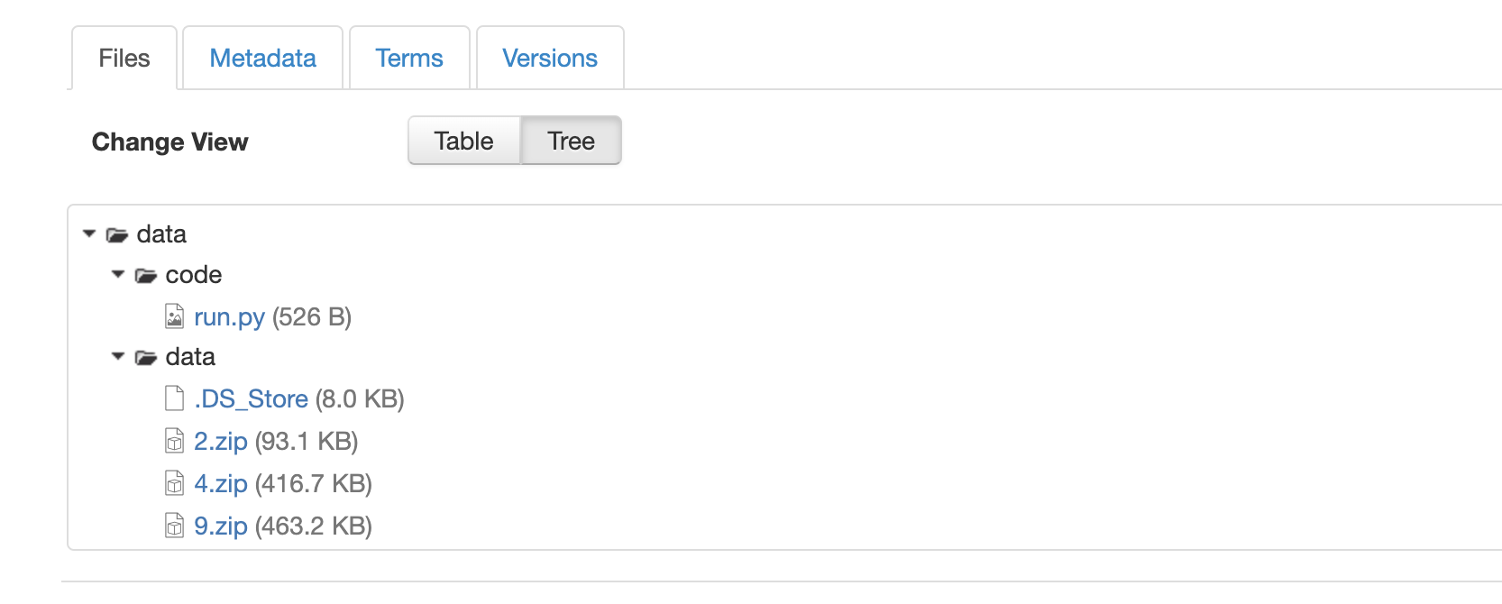

Note: in order to get higher nested structure, you can add multiple “/” to the --tree argument.  
For example:

--tree code/v1/main

And   
 --tree code/v2/main

This is how it will look:

